**Project name: Simulating operations of a Weeding planner and organizer**

**Class- User, Administrator, HR Department, Planner Design, Customer, Maintenance and Services**

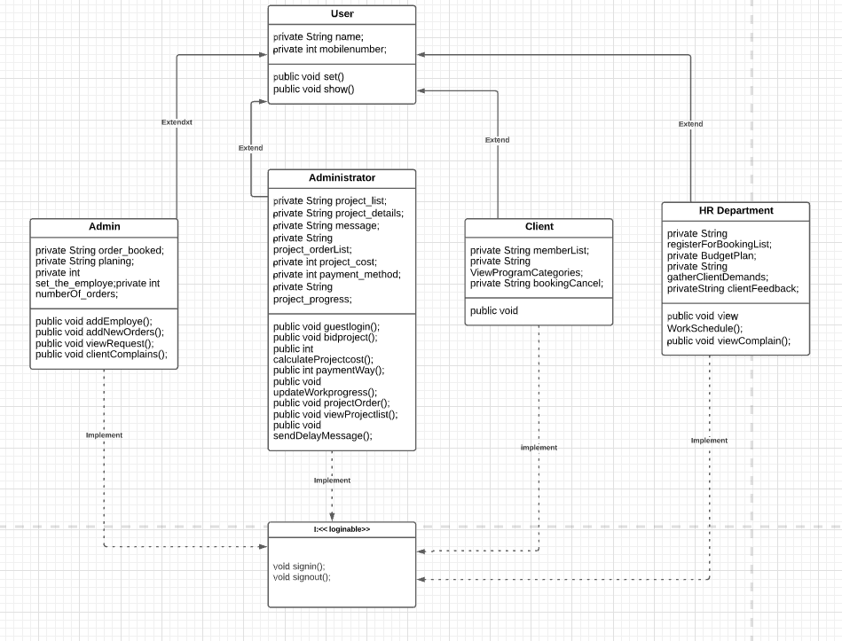

**File Description**

**Program.txt:**

- Text file

- Program information (location, Planing of weeding) it will be stored as a text file using (Character Stream)

**Request.txt:**

- Text file

- Request for id, weeding location will be stored as a text file using (Character Stream)

**Booking.txt:**

- Text file

- Booking information by the user will be store here (Character Stream)

**HRDepartment.txt:**

- Text file

- Adding new employee (Name, age, address, post, salary) will be store as a text file using (Character Stream)

**ProgramPriceList.txt:**

- Text file

- Price details (Planning price wise list, names of plans, ammount) will be store here (Character Stream)

**Client.txt:**

- Text file

- Client information (Client name, contact number, client chose plan) will be store as a text file using (Character Stream)

**ProjectList.txt:**

- Text file

- New project will be added (project code, project cost, project location, project wise sending employee) into text file using (Character Stream)

**Payment.txt**

- Text file

- Fine details (name, amount, payment method (visa/master card/bkash/nogod/checkbook)) will be store here (Character Stream)

**ClientComplain.txt**

- Text file

- Client Complain about planning it will be store here (Character Stream)

**UpdateworkProgress.txt:**

- Text file

- Admin update their work progress which will be store as a text file using here (Character Stream)